# Cyber Security and Ethical Hacking

## VMware Workstation 16 Player

Link:[*https://www.vmware.com/content/vmware/vmware-published-sites/us/products/workstation-player/workstation-player-evaluation.html.html*](https://www.vmware.com/content/vmware/vmware-published-sites/us/products/workstation-player/workstation-player-evaluation.html.html)

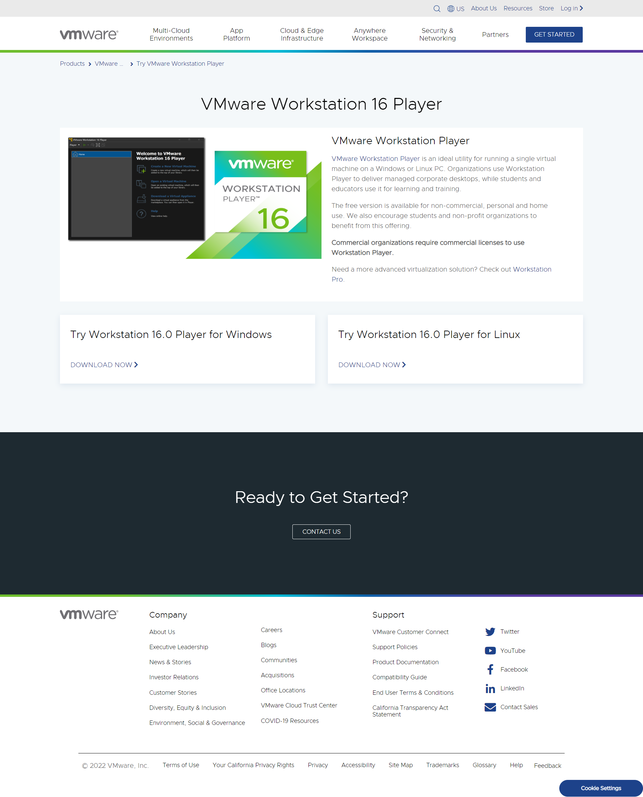

## Kali **Linux** VMware and VirtualBox

Link: [*https://www.kali.org/get-kali/#kali-virtual-machines*](https://www.kali.org/get-kali/#kali-virtual-machines)

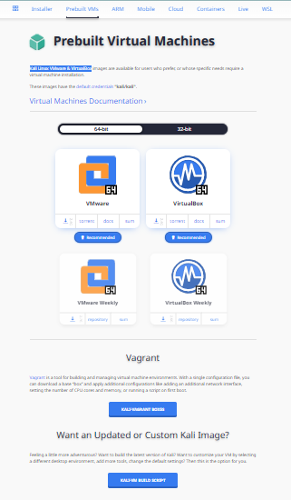

## Get Ubuntu Server

Link: [*https://ubuntu.com/download/server*](https://ubuntu.com/download/server)

